**Squid Proxy**

* **Proxy** : means Represent some one else or deals with somone indirectlly
* **Proxy servers** : Proxy servers operate as an intermediary between a local network and Internet. Requests from local clients for web services can be handled by the proxy server.

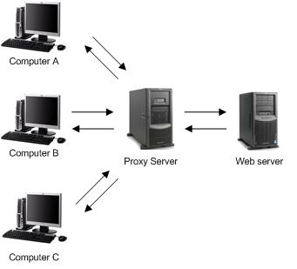

**Proxy servers Uses :**

1. Cache : - (information locally stored, Monitoring and Filtering)

* Speed up the Access
* Save Bandwith

1. Security :- (Actual Server and User more seure and access the internet as a Anonymous Access)
2. Access Control :- (restricted Access)

* whatUser can Acsess
* or Can’t Access on Network

1. Access Enhancement :- (apposite to Access Control means access the restricted access )

Squid is a proxy server for caching and filtering web content . Squid proxy is used by various organisation and internet providers to reduce bandwidth and to increase response time.

**Refer to this Web site : -**

<http://www.krizna.com/centos/how-to-install-squid-proxy-on-centos-6/>

Important Goal of Squid are :-

1. Reduce Inter net Bandwith charges
2. Limit access to the web to only Authorized users
3. Sharing the Internet Connectiion

filters are listed below :

* domains of client or server
* IP subnets of client or server
* URL path
* Full URL including parameters
* keywords
* ports
* protocols: HTTP, FTP
* methods: GET, POST, HEAD, CONNECT

**RULES in squid server**  
    1. allow the network (eg: src )  
    2. Deny the website (eg: dstdomain)  
    3. Deny the Bad Words (eg: url_regex)  
    4. Time resoritation (eg: time)  
    5. password Auth for MD (eg: proxy_Auth)

ACL stands for **Access Control List**

A few important type of ACL elements are listed below

* src : Source i.e. client’s IP addresses
* dst : Destination i.e. server’s IP addresses
* srcdomain : Source i.e. client’s domain name
* dstdomain : Destination i.e. server’s domain name
* time : Time of day and day of week
* url_regex : URL regular expression pattern matching
* urlpath_regex: URL-path regular expression pattern matching, leaves out the protocol and hostname
* proxy_auth : User authentication through external processes
* maxconn : Maximum number of connections limit from a single client IP address

**Q: - How to restrict web access by Time ?**  
  
acl MY_TIME time M T W H F 9:00-17:00

http_access allow MY_TIME

**Q: - What is ufs?**

ufs is a squid storage format